
Dear Parents,
Welcome to my classroom. By now the realization has probably hit that summer is over and the new fall schedule is taking place in all your homes. Earlier bed times, earlier wake times, juggling extracurricular activities and homework, while at the same time trying to keep your sanity! ☺ My goal for curriculum night is to give you an overview of the academics in third grade, new expectations, a peek at fun projects we will be doing and to answer your questions.
I also hope that you walk away feeling as if you know me a bit better and can sleep good at night knowing your child is in the hands of a teacher who is deeply passionate about children! There isn’t a day that goes by where I am not thankful for being blessed with this amazing opportunity to impact children’s lives. I very much look forward to working with you and your child this year and can hardly wait to dive into all the adventures we are going to have together learning in third grade!
Together as a Team We Can Make a Difference!
Folder System:
Every night your child will bring home their “expandable” and assignment book. Please help them stay on top of things by reviewing their assignment book and checking their important notes section with them every day. This is a great way to have a conversation with your child about their busy day. After you have reviewed this with them, please sign your name so I know you completed your homework too! ☺ Other important folders and notebooks your child will occasionally bring home to share are:
- Word Study Notebook- This will be brought home when students have a homework assignment. Otherwise we will use it at school to do most of our work.
- Math Journals- Your child will keep their homework journal at home at all times and rip out pages to send in when they are due. Class journals are kept at school and only taken home when they don’t complete class work on time.
- Writer’s Notebook- This will be brought home when they need more time to finish a story they started in class or when they are publishing their work on their online journal we will be creating.

- Reader’s Notebook- This will be brought home at the end of every unit of study for you to review with your child. This gives you an opportunity to look at the work they have been doing in class, reflect with them on what is going well and what they need to still work on.

Homework:
You should expect that your child will have some type of homework most everyday that will take between 15 and 30 minutes. Please check and sign your child’s assignment book with them every night. Students should be able to do most assignments independently, but do help if it is completely necessary. I will contact you if your child is falling behind or turning in poor work. Please also let me know if your child is spending hours on homework, we will make appropriate adjustments. Please also keep in mind that when they have a test this will add approximately 10 additional minutes of homework.

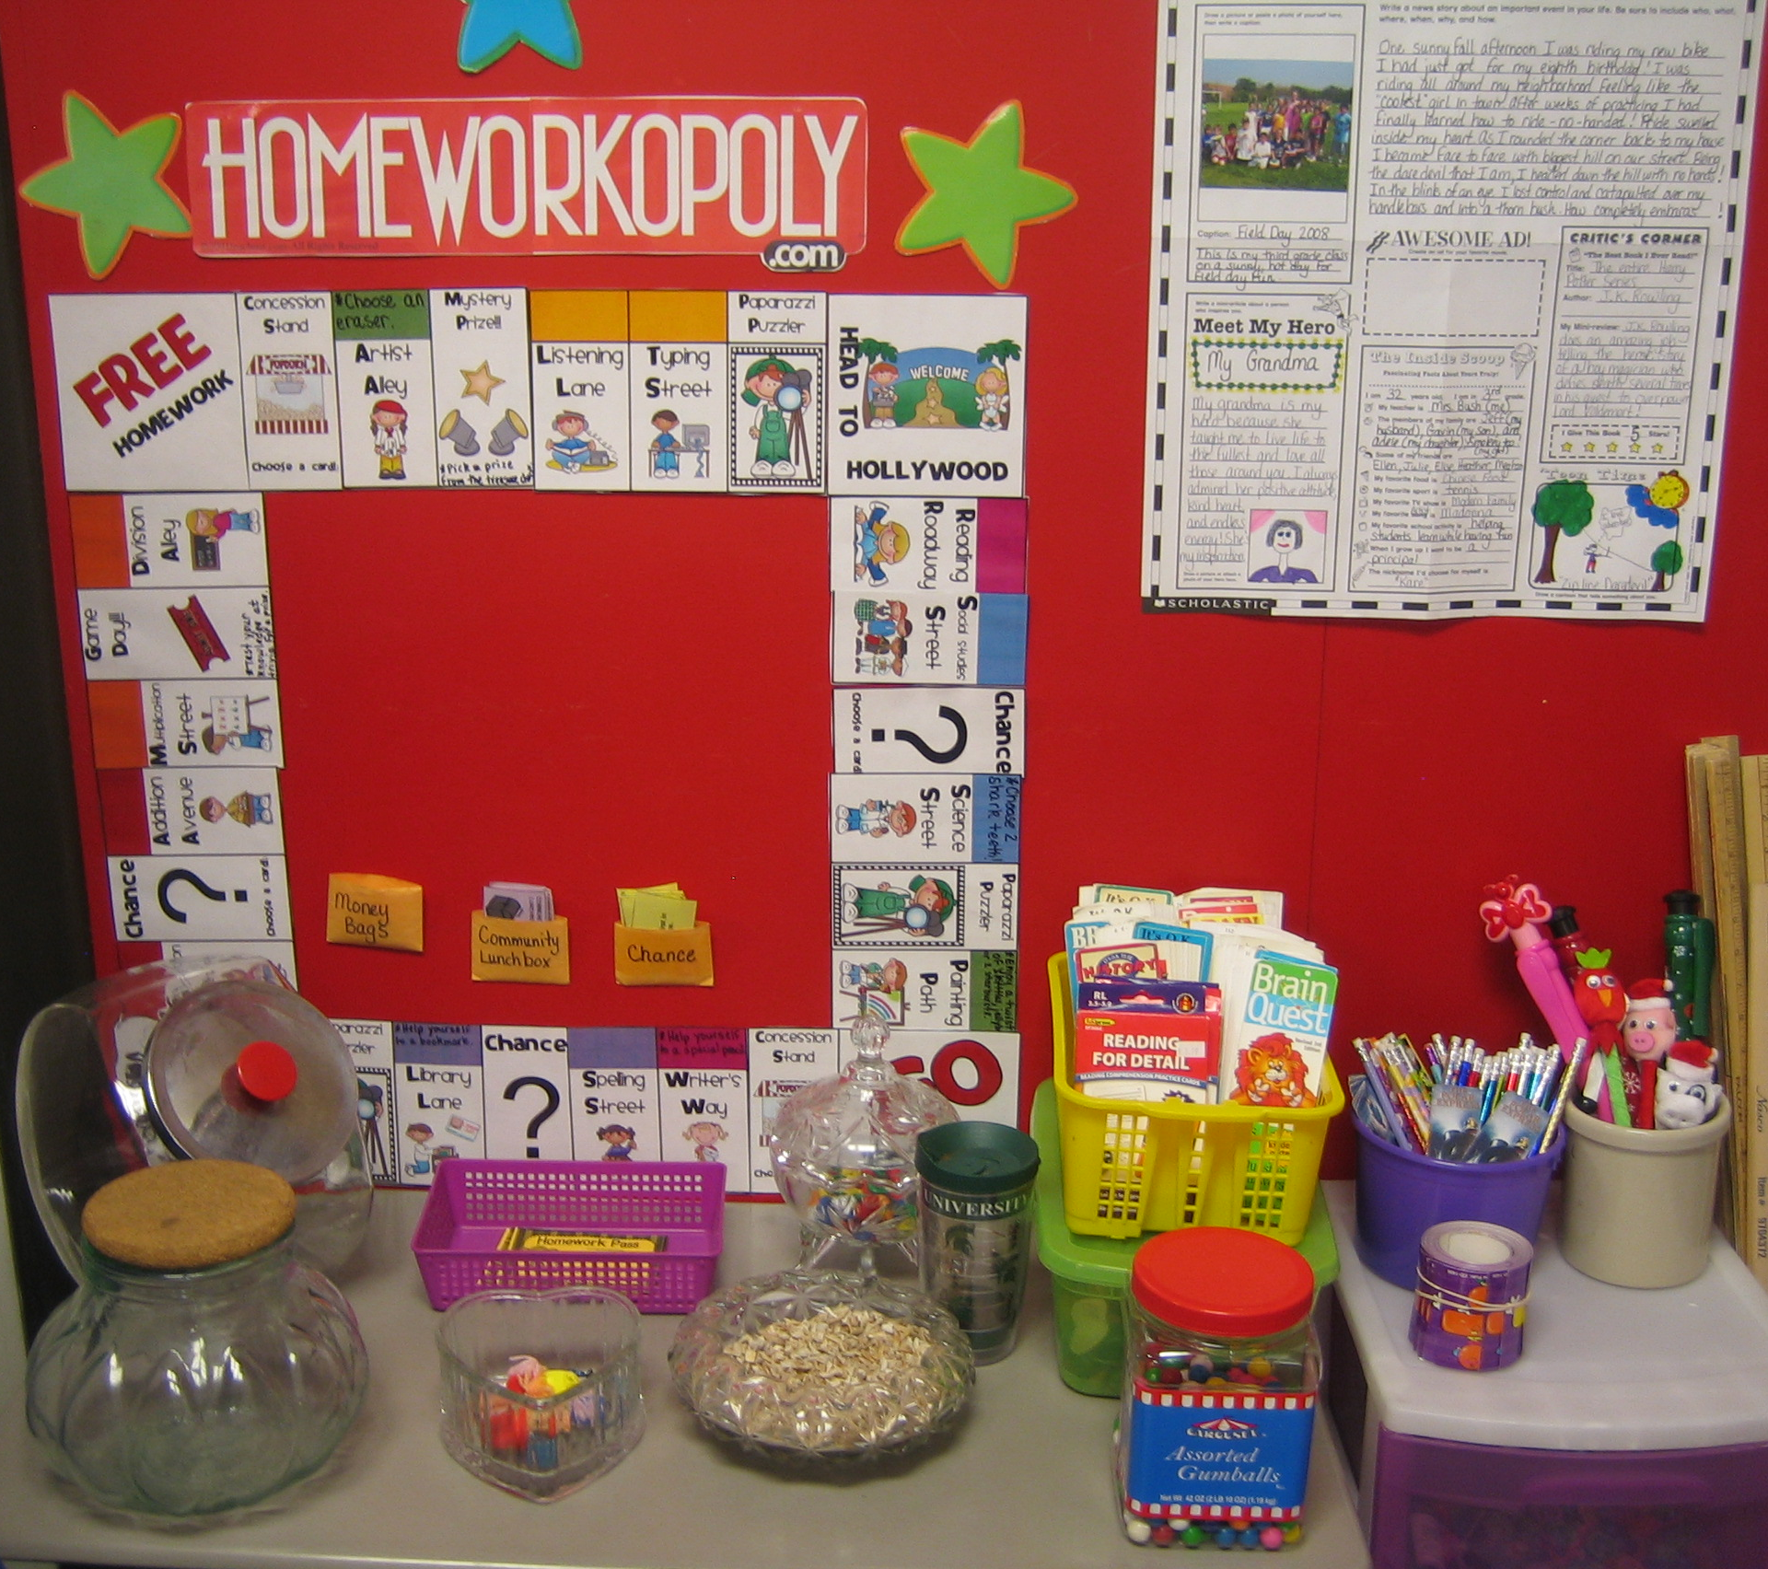
I want to continue to stress the importance that homework is a positive experience, not a punishment, therefore rewarding students who follow directions and get their homework done on time will be a big part of our day. To do this I have adopted the HOMEWORKOPOLY program and implemented its use into our classroom. The rules are simple… If you complete your homework on time than you get to role the die and take a spin around the Homeworkopoly game board. The board is filled with rewards such as free stickers, skittles, pretzels, sitting with a friend at lunch, extra recess… etc. If you forget your homework than you simply don’t get a chance to play and you have a gentle warning to remember to bring in your homework the next day. I will communicate with your through their assignment book or email to notify you of any late assignments.
Classroom Management:
I believe that in order to have a nurturing classroom environment children need positive reinforcement for positive behaviors. Since teamwork is an important 21st Century Literacy Skill I have several ways to celebrate students when they are exhibiting qualities of being a good team player. On a daily basis, students have opportunities to receive smiley face tickets for good work, active participation, awesome effort, lending a helping hand and more! They place their tickets in a jar for our raffle drawing once a week.

You will also notice our bulletin board titled “And the Oscar Goes To…” which will be used to showcase star students for hard work, excellent effort and awesome attitude. Not only are there opportunities where I can reward students and celebrate their accomplishments, but students also have the chance to celebrate each other through our bucket filler program. Students are encouraged to fill out a slip and place it in their classmate’s popcorn bucket when a classmate has “filled their bucket” through a random act of kindness.

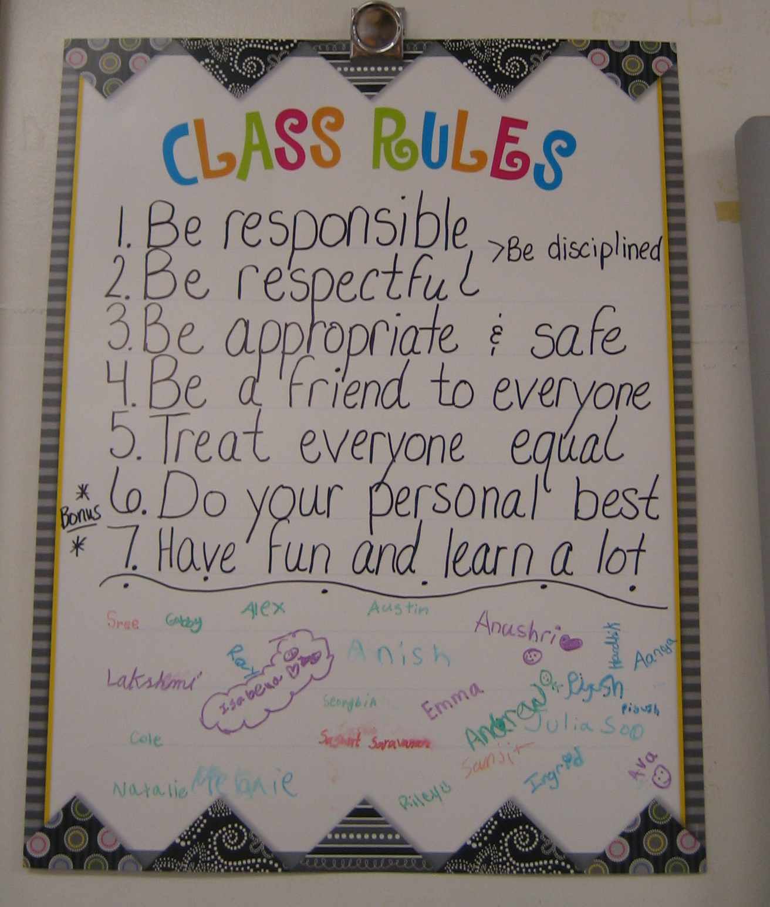
Along with positive reinforcement, children need structure and consequences for inappropriate behavior. I will be operating our classroom under Jim Fays “Love and Logic” plan. Fairness, ownership, problem solving, solution, and individual plans help us run a very smooth and happy classroom. We have seven basic promises in our classroom that we all agreed on during the first week of school.

- Be Responsible 2. Be Respectful 3. Be Appropriate and Safe
4. Treat Everyone Equal 5. Do Your Personal Best 6. Be a Friend to Everyone 7. Have Fun and Learn Lots

After agreeing on the rules we all signed the contract to do our best to follow each one at all times. The poster is easily seen in the classroom to remind us everyday.
Snack:

All students may bring a nutritious snack and a bottle of water to school everyday. Please refrain from sending things like: cookies, candy, cheese curls, donuts, chips, or any chocolate. Some nutritious snack ideas are: dry cereal, vegetables, graham crackers, raisins, granola bars, pretzels, fruit, popcorn, etc.

As a back to school gift I gave all the kids water bottles to keep at school this year so they can stay hydrated all throughout the day. There has been a lot of research that supports water helps children stay focused and energized throughout the day!

Birthday Treats:
Please also give me a heads up at least a day ahead of time if your child is planning to bring a treat for his or her birthday. I love to celebrate birthdays and make your child feel extra special for the day; I just ask that you keep treats simple and already cut up. Birthday cakes are best saved for home celebrations. ☺ Also, if you can avoid the grocery store cupcakes with the mile high frosting, that is also appreciated! I have learned from the past that these are quite messy and can stain clothing. Thank you!!! For my summer birthday children, we will not leave them out; please feel free to celebrate summer birthdays on your child’s half birthday.

Contact Information:

Email: kbush2@troy.k12.mi.us
Phone: 248-823-3618

Looking forward to a great year full of learning and unforgettable memories!

Warmly,

Mrs. Bush

